WEED DETECTION USING MACHINE VISION

INTRODUCTION
Agriculture is the backbone of Indian economy. Agriculture accounts for about 18 % share of the total value of India’s export. It is an important source of livelihood. It contributes about 27% of the total GDP(Gross Domestic Product).
Weeds are the major threat in agricultural field, which diminishes crop growth. Weeds consume excess water, nutrition, minerals and this creates lack of nutrition for crops and reduces the yield.
The weed detection features depends on the position of the plant to determine whether it is a crop or weed. The image of plant is captured and segmented into pixels. After segmentation, the pixels are compared with the threshold value of weed which is predefined in the program and highlights the similar features to determine the weed.
LITERATURE SURVEY
Cloud-Based Architecture for Automated Weed Control Petre Lameski, Eftim Zdravevski, Vladimir Trajkovik and Andrea Kulakov:
This paper projects on the implementing the automated control system which is working based on the cloud based architecture on the acquisition of data and the image annotation. This paper not defines any architecture on agricultural side. This paper gives more focus on annotation and labeling the data as per the image and data collected from the field. There are three algorithms used in this paper for making the comparative investigation, namely semi automated segmentation which realize the images of to and fro with back ground sections of weed and ground. The second algorithm is nearest neighbor based on the pixels and segmentation of the images through which the distribution of pixels on the front and back side of weed and ground is analyzed. The third algorithm is K-D tree approach on method two specifies above to find the distribution parameter on the weeds and foreground. The mixed algorithm grabcut is used, which is not a optimized choice on the leaves which are overlapped since the overlapping makes the datasets are more complex and tends the much variation on the pixels and also the segmentation algorithm grabcut is not suitable for the RGB colored images and to the reference of learning methodology it uses the supervised learning that obtain certain classes of objects. Hence the algorithm on annotation is classified for the best identifying the pixels of the segmented weed based on the segmentation and does not focus on the methodology to predict the quality.
Implementation of Image Processing Technique in Real Time Vision System for Automatic Weeding Strategy Mohd. Marzuki Mustafa, Aini Hussain, Kamarul Hawari Ghazali, Slamet Riyadi
The proposed system focus on the intelligent system on weed productivity and quality analysis and the mission vision based mechanical system is developed to support the productivity in both terms of qualitative and quantitative, henceforth the system design uses the basic technology on processing the images by implementing the various algorithms such as GLCM,FFT which gives the less optimum results. The technology preferred was not preferable to identify the level of accuracy hence the algorithm itself have difficulty on image segmented analysis
Weed detection using image processing by Ajinkya Paikekari, et al.,

Weeds are classified based on the extracted images based on the parameters such as size, and the shape along with the color. This paper provides the classification of images based on the machine learning algorithm like SVM & KNN method. This paper provides the methodology on detection of weed quality based on images based on the prediction and mainly the color algorithm prefers is based on 2G-B, and the image features extracted by using this image is lower in optimized value. Color segmentation and edge detection techniques have been implemented to identify weed among crops. The location of weed is identified and confirmed to spray the herbicide, this further reduces the soil nourishment. The position of weed is not clearly defined and this may damage the crop growth and results in reduced yield.

Removal of weeds using Image Processing by Riya Desai, et al.,
Identification and classification of weeds can be done by image segmentation. The common features used to identify the presence of weed is color, shape, position and size. The automatic locataion of weed is not identified and hence manual work is required to remove the weeds.
Crop and Weed Detection Based on Texture and Size Features and Automatic Spraying of Herbicides by Amruta A.
Aware Five texture features are used for detection of crop. These five features are energy, entropy, inertia, local homogeneity and contrast. Morphological size based features are also used for detection of crop and weed. Comparing the results, detection of crop and weed is identified
In [3] author “Crop detection by machine vision for weed management” weed could be detected by using machine vision technique. Machine vision uses unique image processing technique. Weeds in agricultural field had detected by its properties such as Size, Shape, Spectral Reflectance, Texture features. In this document they have demonstrated weed detection by its Size features. After the image acquisition Excessive green algorithm was developed to remove soil and further avoidable things from the image. Image enhancement techniques are used to eliminate Noise from the images, By using Labeling algorithm each components in the Image were extracted, then size based features like Area, Perimeter, longest chord and longest perpendicular chord have calculated for each label and by selecting suitable threshold value Weed and Crop segmentation is done.

In [4] author proposed “Detection of Weeds in a Crop Row Using Image Processing” weed control was essential and critical operation and could affect crop yield. This document proposed two methods: crop row detection in images from agriculture fields with high weed difficulty and to further differentiate between weed and crop. Firstly, for crop row detection the image processing includes three main processes: image filtering, image segmentation using Otsu’s method, and crop row detection. Secondly, further classification among weed and crop, is carried out by using box plotting technique. The proposed technique was tough against lighting due to environmental conditions.
In [5] author proposed “Crop and weed detection based on texture and size features and automatic spraying of herbicides” they developed the image processing algorithm for yield finding and management of weed. Five texture features are used for detection of crop. These five features are energy, entropy, inertia, local homogeneity and contrast. Morphological size based features are also used for detection of crop and weed. Compared the all results and taken majority decision for detection of crop and weed. Image segmentation combines image processing techniques in categorizes to take out cell from the image. The decision making determines the cells to be sprayed. Further the Cartesian robot manipulator is developed to locate the weed position on real field by calculating the coordinates to selectively spray the herbicides. In [6] author proposed “A computer vision application to detect unwanted weed in early stage crops” application for computer vision to detect unnecessary weed in crops from one area with extra agricultural impact. An Image processing was developed to get the region of attention were finally processed throughout neural networks. He proposed some methods like image acquisition, segmentation and ANN. They improved in the method by applying herbicides, in the exacting case of this application, image processing was a important aspect since obtaining the mask and the identification of regions of interest, taking same levels of light intensity, and it was a major challenge. In [7] author proposed “A Novel approach for weed classification using curvelet transform and tamura Texture feature (CTTTF) with RVM classification” weed is a surplus plant growing along with the useful agriculture products. These weed also consume the water from the soil which will direct to in adequate water for the useful agroproducts, for this reason these weeds would be identified earlier and removed. This document present an efficient curvelet make over and patch level tamura texture feature extraction method for weed classification. The relevance vector machine classification technique was developed for crop and weeds classification and weed partition. The results were compare support vector machine and with random forest classifier technique. The planned method outperforms all the other transform in conditions of correctness, specificity and sensitivity.

Proposed technique
The main aim of this project is to identify the location of weeds among crops. The approach of the project includes achieving a baseline method for developing a real time weed detection system through binary classification. Image is captured using camera, The digital images were captured in outdoor light conditions with perspective projection over crop. Captures have 8MP resolution in RGB color space with JPG extension. The captured image is converted to HSV image. Then image is segmented using excessive green colour segmentation. Further image is converted into gray scale image. Grey scale image is given as input to ‘Gray level co-occurrence matrix’.
- Contrast
- Correlation
- Energy
- Homogeneity
Block diagram
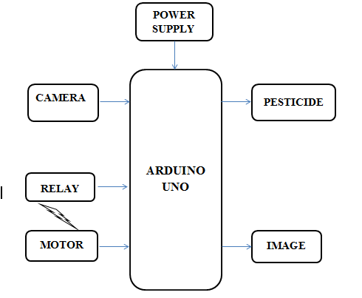
HSV image of weed
Hue is therefore the actual color. Brightness refers to how much white or black is mixed in the color, while Saturation indicates the amount of grey in a color. A saturation value of 0 indicates mostly grey while 100% luminosity (or L = 255) is white.
H - Hue
S - Saturation
V – Value
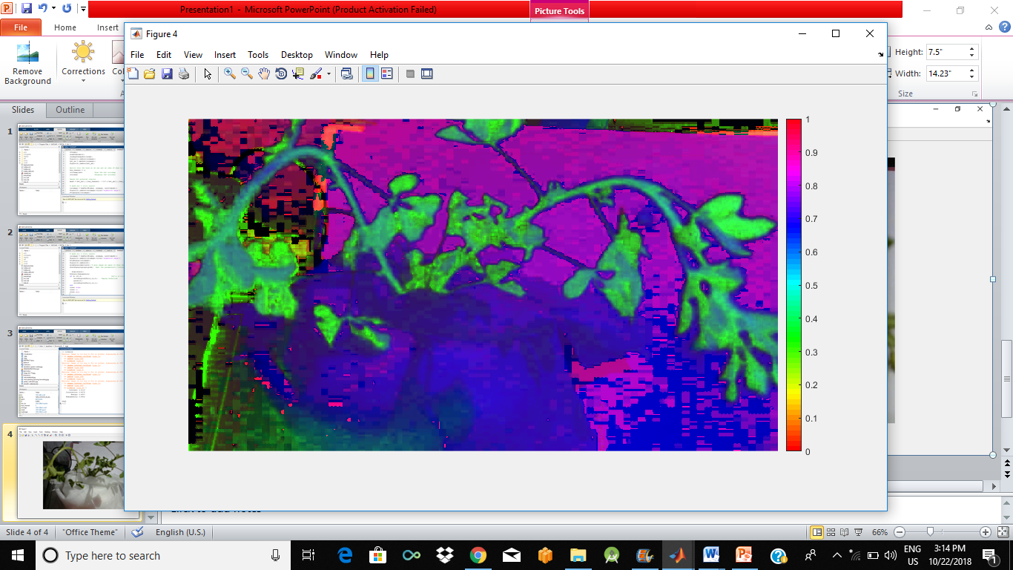
Segmented image of weed
In computer vision, image segmentation is the process of partitioning a digital image into multiple segments . The goal of segmentation is to simplify and change the representation of an image into more meaningful and easier image to analyze.
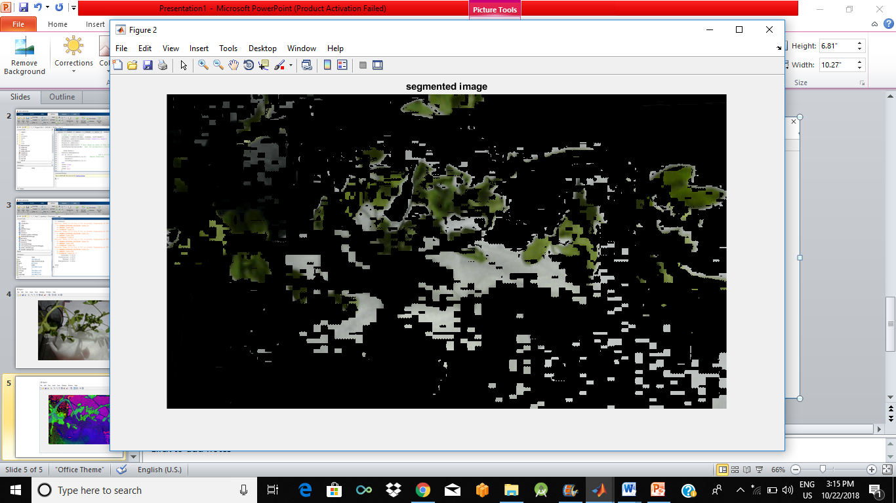
Gray image of the weed
A gray scale image is simply one in which the only colors are shades of gray. The reason for differentiating such images from any other sort of color image is that less information needs to be provided for each pixel.
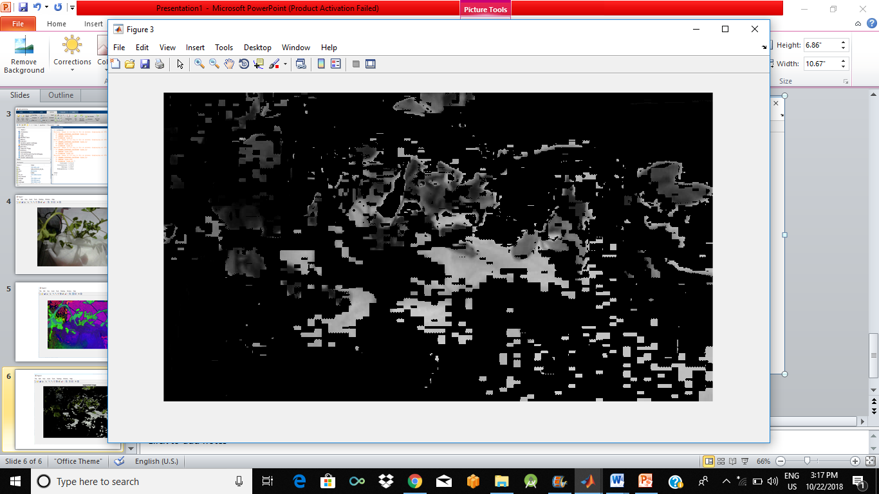

RESULT AND DISCUSSIONS
The proposed system is used in weed detection . The major loss of crops can be over come by this technique . The system captures the image of every weed and process the image to obtain HSV image, segmented image, gray image. The system analyses the image of the weed and sprays pesticide for the weed to stop its future growth. Hence this system will improve agriculture and increases the growth of crops by controlling weed growth.
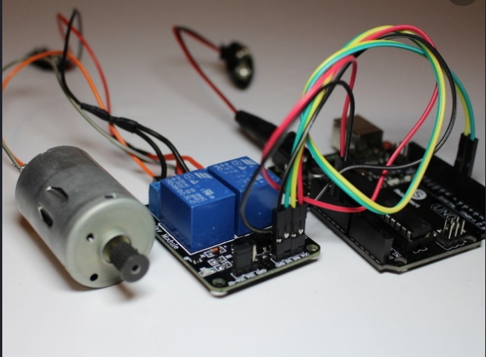

CONCLUSION
The proposed system ensures the presence of weed by contrast, color, homogeneity. The image captured is processed using machine vision and plant is identified either to be crop or weed by image segmentation. The final gray image indicates the presence of weed, the location of weed is clearly identified and pesticide is sprayed to diminish the growth of weed. The system enhances growth of crops and increases the yield. The system uses rotating camera and avoids obstacles during weed detection.

